--------------If Else -------------------

1) Write a program to check whether a person is eligible for voting or not.

(accept age from user)

2) Write a program to check whether a number entered by a user is even or odd.

3) Write a program to check whether a number is divisible by 7 or not.

4) Write a program to display "Hello" if a number entered by user is

a multiple of five ,otherwise print "Bye".

5) Write a program to calculate the electricity bill (accept number of unit from user) according to the following criteria :

Unit Price

First 100 units no charge

Next 100 units Rs 5 per unit

After 200 units Rs 10 per unit

(For example if input unit is 350 than total bill amount is Rs2000)

6) Write a program to check whether the last digit of a number

(entered by user ) is divisible by 3 or not.

7) Write a program to determine whether a number (accepted from the user)

is divisible by 2 and 3 both.

8) Accept the age of 4 people and display the youngest one?

9) Accept the age of 4 people and display the oldest one.

10) Write a program to check whether an years is leap year or not.

11) Write a program to check whether a number entered is three digit number or not.

12) Write a program to check whether a person is senior citizen or not.

13) Write a program to accept two numbers and mathematical operators and perform operation accordingly

Like: Enter First Number: 7

Enter Second Number : 9

Enter operator : +

Your Answer is : 16

Pattern Questions:

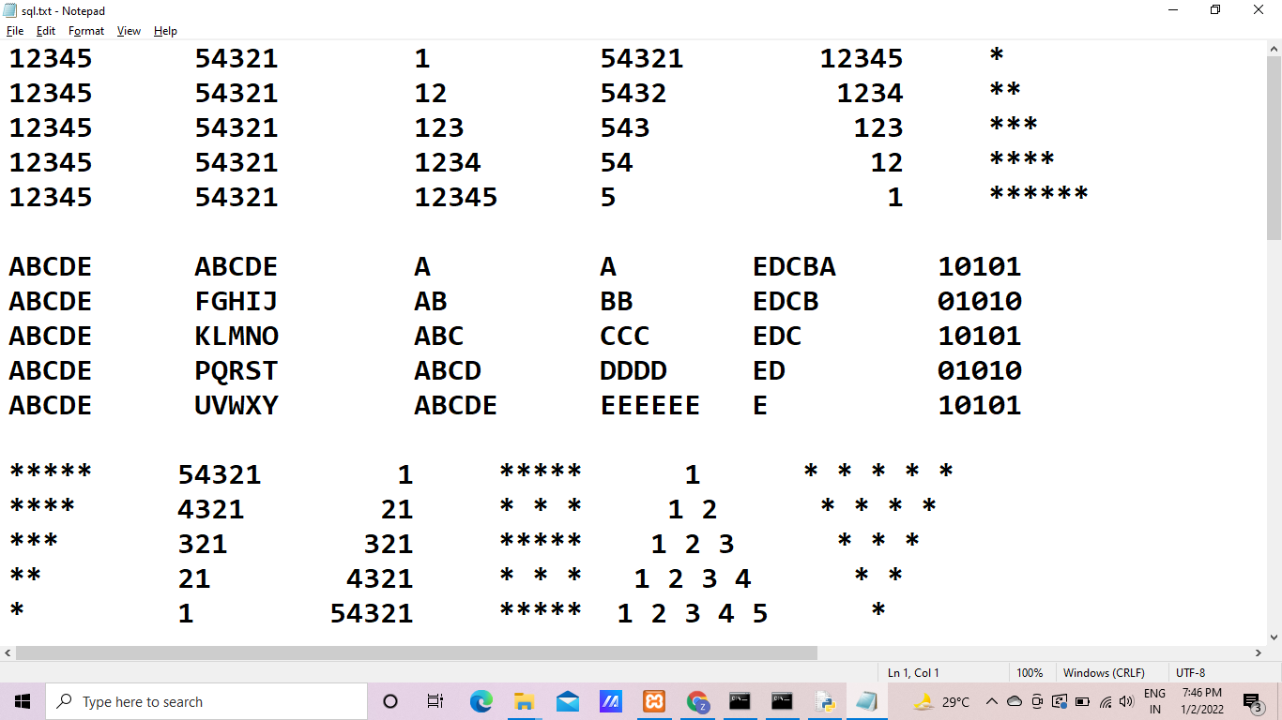

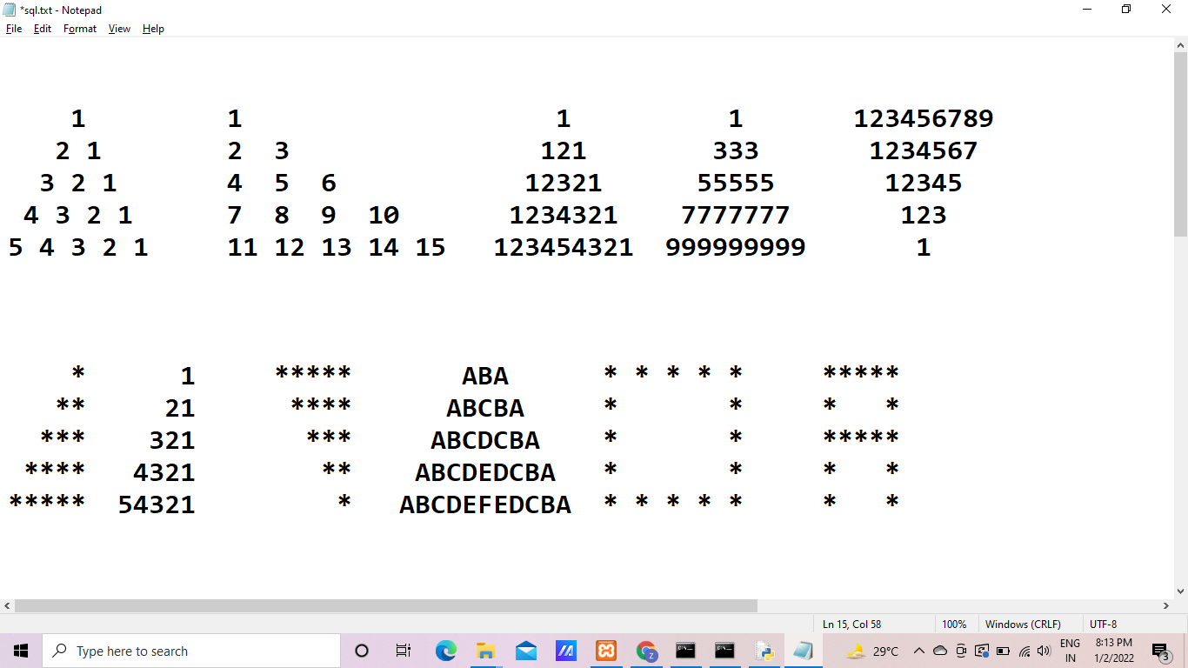

Basic Question:

1. Take a number from the user, check if it is prime or not using a break statement.
2. Take a number from the user, check if it is prime or not without using a break statement.
3. Create a function which accept number or check it prime or not using recursion without using loop
4. Create a function which accept any 5 element and print in ascending or descending
5. Create a function which accepts any array with five number and print largest number from array.
6. Create a function which accepts any array with five numbers and prints the largest odd number from the array.
7. Create a function which accepts any String or print in reverse order. Eg. coder O.P: redoc
8. Create a function which accepts any String or print in reverse order. Eg. itvedant team O.P: maet tnadevti
9. Create a function which accepts any String or print in reverse order. Eg. Itvedant Item O.P: tnadevti metI
10. Create a function which accepts any String or print in reverse order. Eg. Itvedant Item O.P: Item Itvedant
11. find 2nd Largest Number in Array
12. find the Sum of Array in Java
13. Sum of Two Arrays Elements
14. Count Even and Odd numbers in an Array
15. Put Even and Odd Elements in 2 Separate Arrays
16. Display Even and Odd numbers in an Array
17. Sum of Even and Odd Numbers in Array in Java
18. Remove odd numbers from an array Java
19. Count positive negative and zero from Array
20. Print all negative elements in an array
21. Separate positive and negative numbers in an array
22. Find the sum of positive numbers in an array
23. The cumulative sum of an array in Java
24. Find numbers that are greater than the given number from an array
25. Find average and numbers greater than average in array
26. How to Sort an Array in Java
27. Reverse an Array in Java
28. How to merge two arrays?
29. How to fill (initialize at once) an array?
30. How to extend an array after initialisation?
31. How to sort an array and search an element inside it?
32. How to remove an element of array?
33. How to remove one array from another array?
34. How to find common elements from arrays?
35. How to find an object or a string in an Array?